Spring Architecture:
- Spring could potentially be a one-stop shop for all your enterprise applications. However, Spring is modular, allowing you to pick and choose which modules are applicable to you, without having to bring in the rest.
- The Spring Framework provides about 20 modules which can be used based on an application requirement.

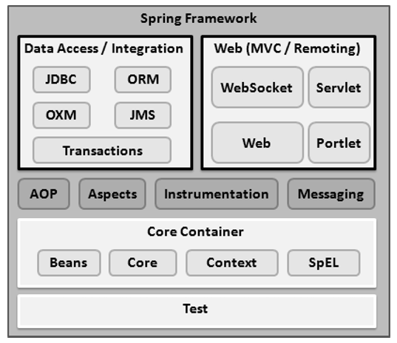
Core Container:
- Core - provides the fundamental parts of the framework, including the IoC and Dependency Injection features.
- Bean - provides BeanFactory, which is a sophisticated implementation of the factory pattern.
- Context - builds on the solid base provided by the Core and Beans modules and it is a medium to access any objects defined and configured. The ApplicationContext interface is the focal point of the Context module.
- SpEL - provides a powerful expression language for querying and manipulating an object graph at runtime.

Data Access/Integration:
- JDBC - provides a JDBC-abstraction layer that removes the need for tedious JDBC related coding.
- ORM - provides integration layers for popular object-relational mapping APIs, including JPA, JDO, Hibernate, and iBatis.
- OXM - provides an abstraction layer that supports Object/XML mapping implementations for JAXB, Castor, XMLBeans, JiBX and XStream.
- Java Messaging Service(JMS) - contains features for producing and consuming messages.
- Transaction - supports programmatic and declarative transaction management for classes that implement special interfaces and for all your POJOs.

Web:
- Web - provides basic web-oriented integration features such as multipart file-upload functionality and the initialization of the IoC container using servlet listeners and a web-oriented application context.
- Web-MVC - contains Spring's Model-View-Controller (MVC) implementation for web applications.
- Web-Socket - provides support for WebSocket-based, two-way communication between the client and the server in web applications.
- Web-Portlet - provides the MVC implementation to be used in a portlet environment and mirrors the functionality of Web-Servlet module.

Miscellaneous:
- AOP - provides an aspect-oriented programming implementation allowing you to define method-interceptors and pointcuts to cleanly decouple code that implements functionality that should be separated.
- Aspects - provides integration with AspectJ, which is again a powerful and mature AOP framework.
- Instrumentation - provides class instrumentation support and class loader implementations to be used in certain application servers.
- Messaging - provides support for STOMP as the WebSocket sub-protocol to use in applications. It also supports an annotation programming model for routing and processing STOMP messages from WebSocket clients.
- Test - supports the testing of Spring components with JUnit or TestNG frameworks.

